# [**Mariska Hargitay and Christopher Meloni's Off-Screen Friendship Proves They're Partners for Life**](https://www.eonline.com/amp/news/1164703/mariska-hargitay-and-christopher-melonis-off-screen-friendship-proves-theyre-partners-for-life?__twitter_impression=true&s=09)

The long-time partners on *Law & Order: SVU* have each other's backs just as much off-screen as they did while starring on the show together.

**By** [**KELSEY KLEMME**](https://www.eonline.com/authors/kelsey-klemme) **AUG 15, 2020 1:00 PM**

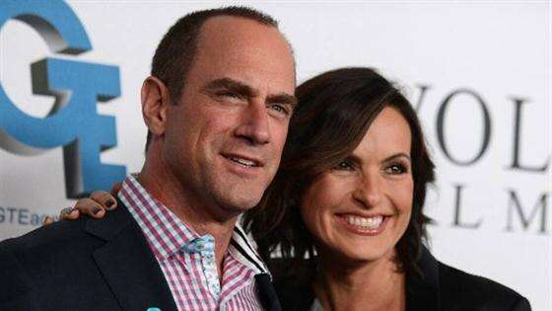

**Related:** Mariska Hargitay Welcomes Chris Meloni Back to "Law & Order"

Stabler and Benson forever!

It's been 9 years since [**Christopher Meloni**](https://www.eonline.com/news/christopher_meloni)left *Law & Order: SVU*, but thankfully his friendship with [**Mariska Hargitay**](https://www.eonline.com/news/mariska_hargitay) has never ended.

The two still frequently hang out, from grabbing dinner to going on vacays, and we're always happy when the stars share pics for those of us who still miss seeing their [**partner-in-crime bond**](https://www.eonline.com/news/1161693/law-and-order-organized-crime-will-have-stabler-adapting-to-criminal-justice-system-s-quot-reckoning-quot?query=law%20and%20order) on the long-running procedural.

Thankfully, though, [**fans of the series**](https://www.eonline.com/news/1144060/everything-you-ve-ever-wanted-to-know-about-being-on-law-and-order-svu) can rejoice and relive the actors' best moments together on-screen, as the stalwart series is available to stream now on [**Peacock**](https://www.peacocktv.com/)!

That's right, you can rewatch Hargitay, Meloni and their co-stars [**Ice-T**](https://www.eonline.com/news/ice-t)**, BD Wong, Peter Hermann** (who is also Hargitay's husband!), **Kelli Giddish, Peter Scanavino** and more as they work together to stop New York's most heinous offenses any time on NBCU's streaming service.

In celebration, let's take a look back at Meloni and Hargitay's real-life friendship with their cutest BFF pics.

So take a look below, and be sure to sign up for [**Peacock**](https://www.peacocktv.com/) so you can binge the series all over again.



[**PHOTOS**](https://www.eonline.com/photos/23800/how-law-and-order-svu-handled-cast-exits)

[**How *Law and Order: SVU* Handled Cast Exits**](https://www.eonline.com/photos/23800/how-law-and-order-svu-handled-cast-exits)

(E!, Peacock and NBC are all part of the NBCUniversal family.)

[**Peacock is live now! Check out NBCU's new streaming service here.**](https://www.peacocktv.com/?cid=20200101evergreensymseo241&utm_source=symphony&utm_medium=symphony_seo_brandawareness_articlebacklink&utm_campaign=20200101evergreen&utm_term=eonlineusers&utm_content=eonllinebacklink)

#### ***TRENDING STORIES***



**1**

### [**Japanese Actress Yuko Takeuchi Dead at 40: Reports**](https://www.eonline.com/news/1192380/japanese-actress-yuko-takeuchi-dead-at-40-reports)

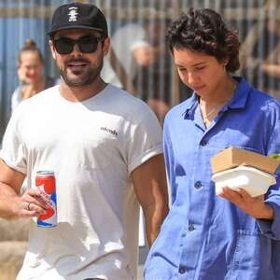

**2**

### [**Stars Who've Dated Normal People**](https://www.eonline.com/news/1192214/stars-whove-dated-normal-people)

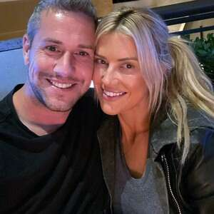

**3**

### [**Ant Anstead Breaks His Silence Over Christina Anstead Divorce**](https://www.eonline.com/news/1192344/ant-anstead-breaks-his-silence-over-christina-anstead-divorce)

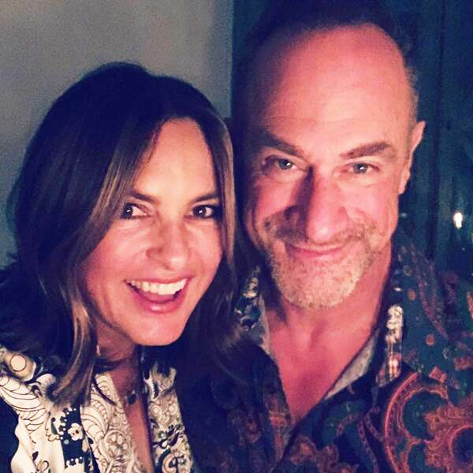Mariska Hargitay / Instagram

**Dinner Party**

"Sunday night dinner," **Mariska Hargitay** shared alongside a selfie of her and **Chris Meloni**, who she starred with on *Law & Order: SVU* for 12 seasons before the actor left the series in 2011.

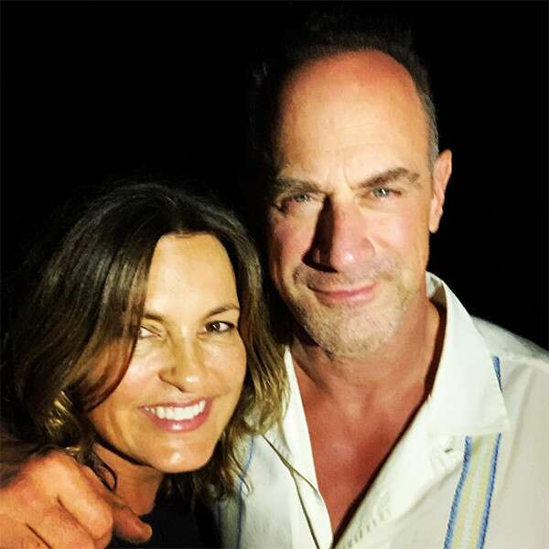Instagram

**Vacation Buddies**

Hargitay posed this [**snap**](https://www.instagram.com/p/Br_wOjRHkkn/) with her bestie while on vacation in December 2018 and we're obsessed. "Vacay...A great night with this one. #Reunited #OldFriends #PTL," she captioned it.

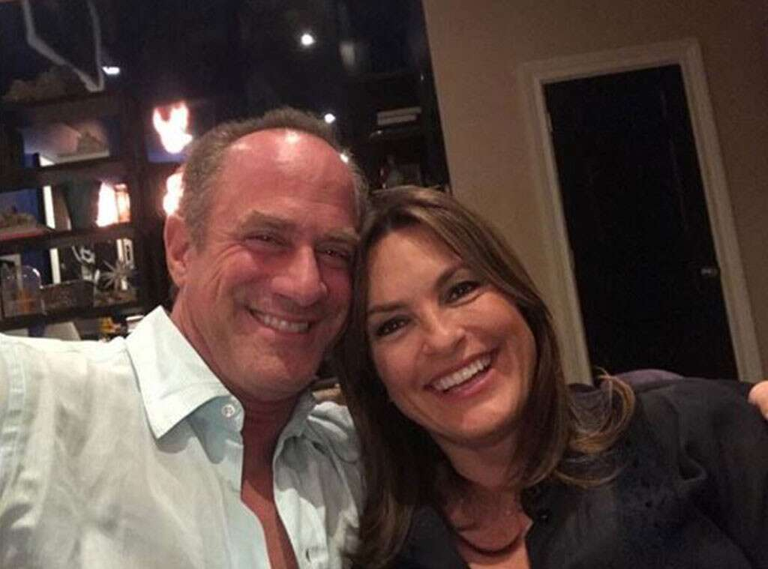Instagram

**Partners for Life**

In May 2018, Meloni and Hargitay hung out together in New York City and of course they documented it...thank goodness.

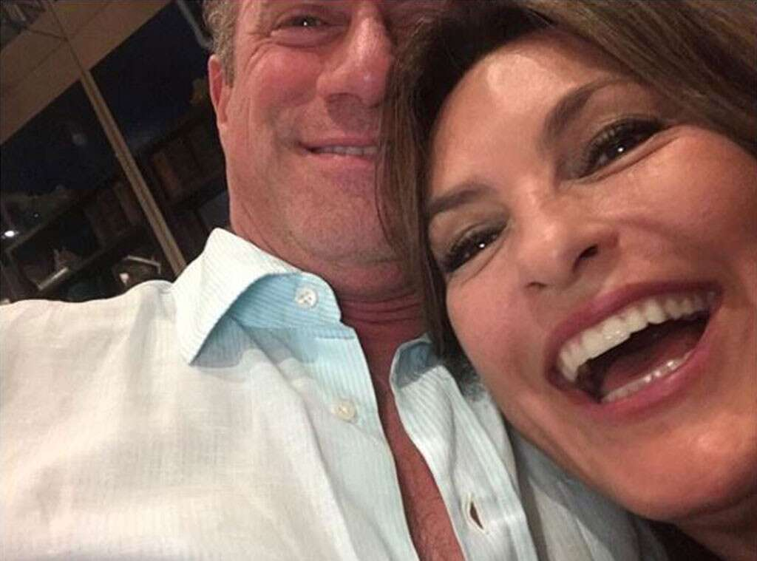Instagram

**Selfie Fail**

"Crazy ppl on the streets of nyc," Meloni [**captioned**](https://www.instagram.com/p/BjYx9bFhKgw/?taken-by=chris_meloni) this selfie fail and seriously, how can you not just love these two together?

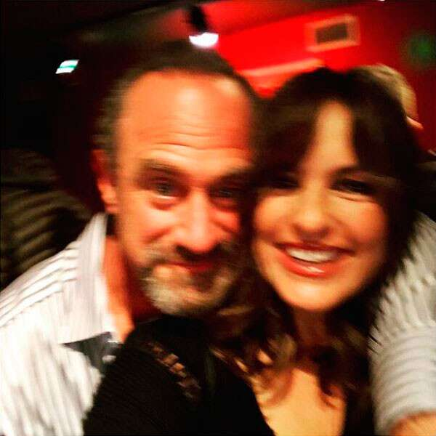Instagram

**Blurry Buds**

Blurry or not, this snap of the two former *Law & Order: Special Victims Unit* co-stars spending time together during the holidays in 2017 is too cute.

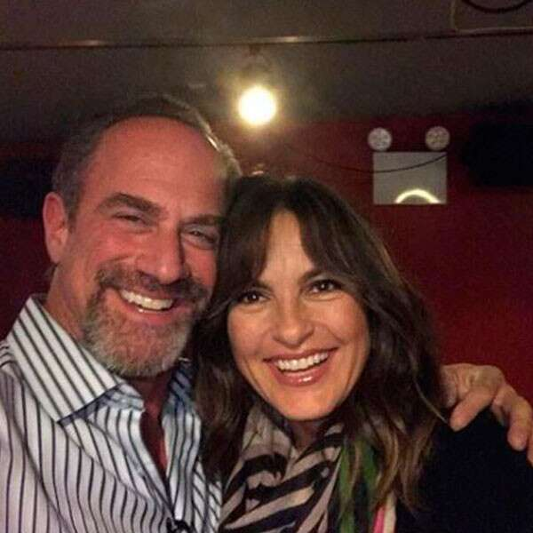Instagram

**Happy and They Know It**

After Thanksgiving in 2017, the two pals ran into one another and clearly they still have fun no matter what the occasion.

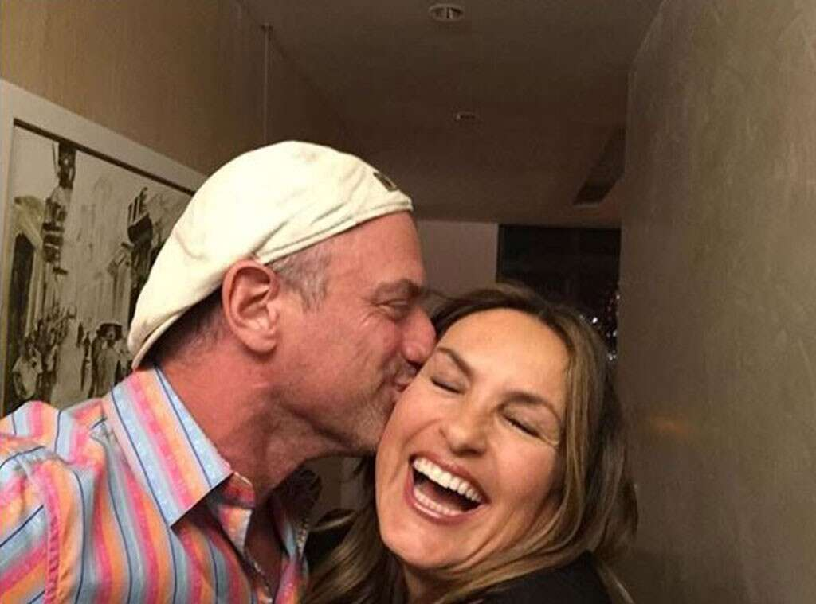Instagram

**Kiss Kiss**

Ugh, how do we get Detective Stabler to give us a smooch?

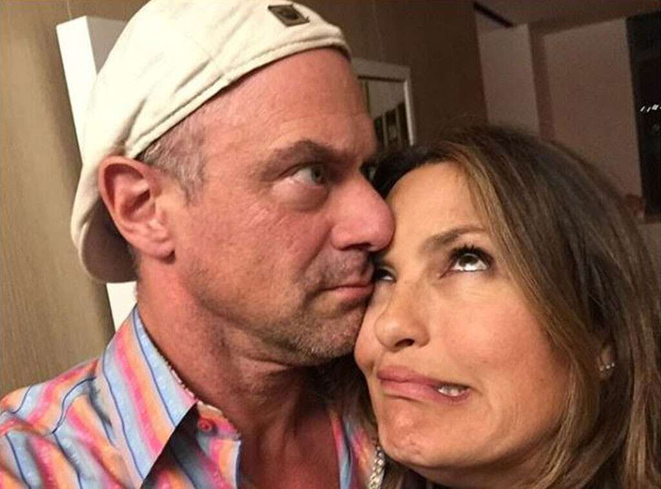Instagram

**Goofballs Forever**

"Even the effortless moments..." Meloni [**captioned**](https://www.instagram.com/p/BTcXrQfjdVQ/?taken-by=chris_meloni) the previous photo only to follow it up with this funny picture and the [**caption**](https://www.instagram.com/p/BTcXuXwje6C/?taken-by=chris_meloni), "...need to be rehearsed."

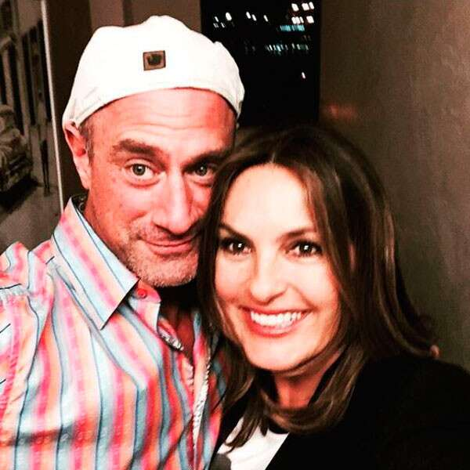Instagram

**Birthday Bash**

Hargitay shared this sweet snap in honor of her former TV partner's birthday in April 2017 and said "PFL" at the [**end of the note**](https://www.instagram.com/p/BSXouv4j8_8/?taken-by=therealmariskahargitay) and we're dying a little inside because Stabler and Benson *are* partners for life!

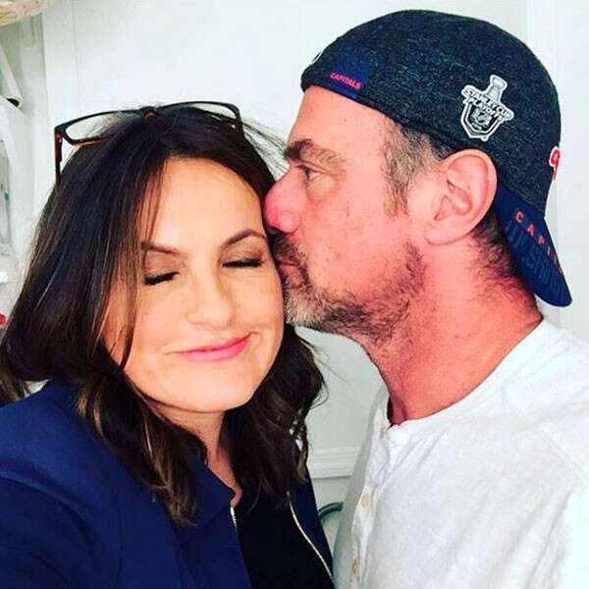Instagram

**Be Mine**

"And then that happened...Just when I thought Valentine's Day was over," Hargitay [**wrote**](https://www.instagram.com/p/BQjI-d9FF-N/?taken-by=therealmariskahargitay) alongside this kissing picture from Valentine's Day in 2017 and we are again getting teary-eyed at these two loving each other so much.

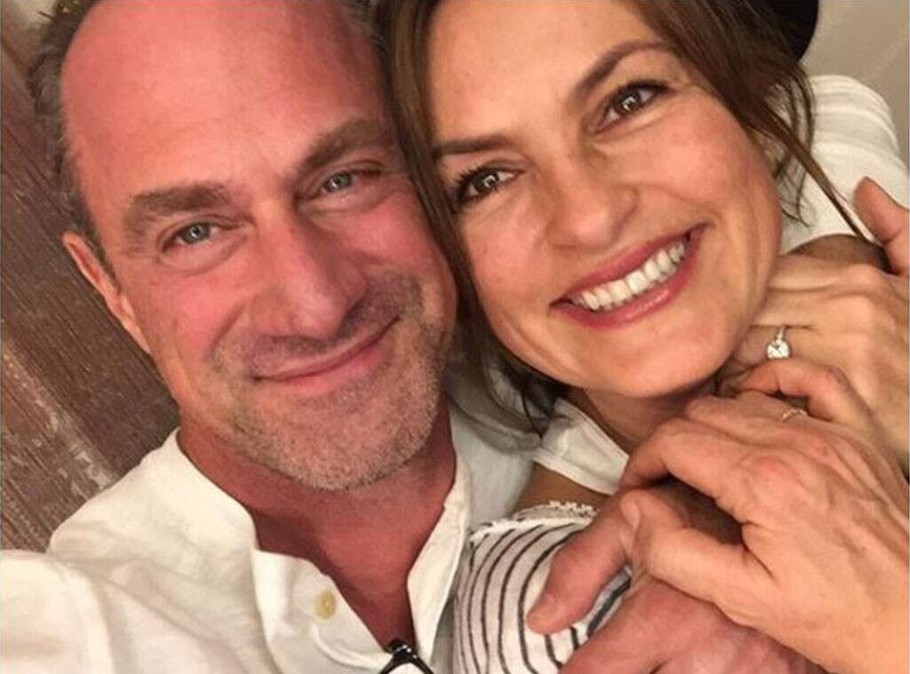Instagram

**Stabler & Benson for President**

In 2016, the former TV partners and real-life friends celebrated Christmas together (well, a few days early) and we are in desperate need of an on-screen reunion now.

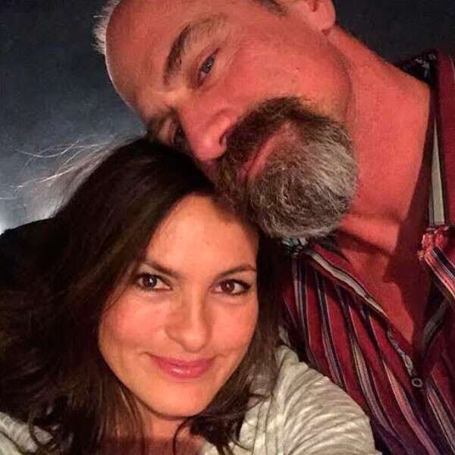Instagram

**Friendly Run-ins**

"Lean on me #PFL #FacialHairDontCare #Hargoatee #HanginWithAFriend #ItsAllInTheEyesKid," Hargitay [**wrote**](https://www.instagram.com/p/BC1BMFMkK-S/?taken-by=therealmariskahargitay) on this precious picture and we will never get tired of these quick reunions.

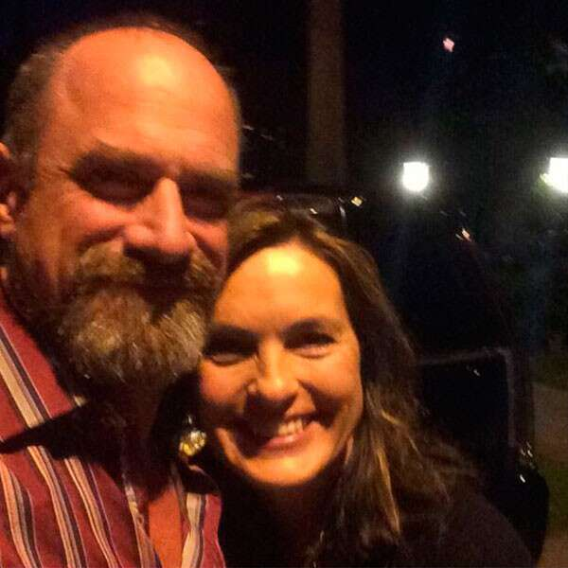Instagram

**Spotted: *SVU* Pals**

In 2015, in the dark of night, New York City's greatest detectives, err, we mean friends, reunited once again and posed for an epic photo.

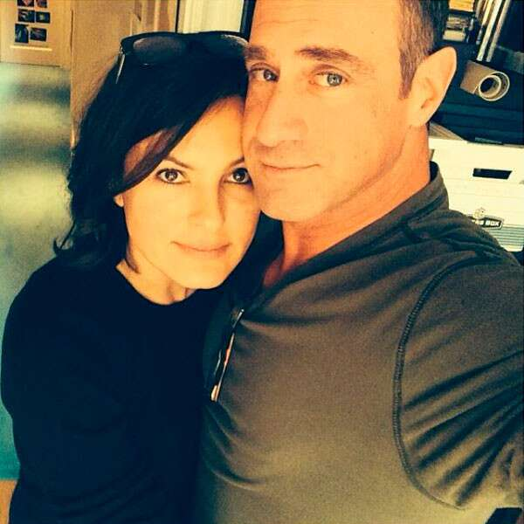Instagram

**Ride or Die**

It doesn't matter how long these two are apart, they always make time to check in with each other and we are totally on board with all the run-ins that have happened over the past few years.

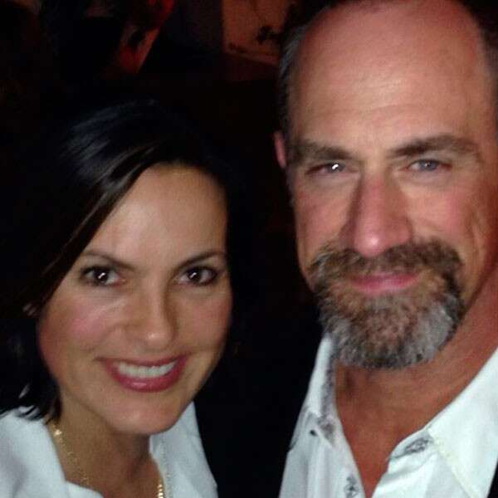Instagram

**Bestie Reunions**

In March 2014, the duo reunited for dinner proving that they will always be partners, even if they aren't acting alongside one another anymore.